1.



OnePlus Nord N10 5G cell phone was dispatched on 26th October 2020. The telephone accompanies a 6.49-inch touchscreen show. OnePlus Nord N10 5G is controlled by an octa-center Qualcomm Snapdragon 690 processor. It accompanies 6GB of RAM. The OnePlus Nord N10 5G runs Android 10 and is fueled by a 4300mAh battery. The OnePlus Nord N10 5G backings exclusive quick charging.

All things considered, the OnePlus Nord N10 5G on the back packs a 64-megapixel essential camera; a 8-megapixel camera; a 2-megapixel camera, and a 2-megapixel camera. The back camera arrangement has self-adjust. It sports a 16-megapixel camera on the front for selfies.

The OnePlus Nord N10 5G runs OxygenOS 10.5 depends on Android 10 and packs 128GB of inbuilt stockpiling that can be extended through microSD card (up to 512GB). The OnePlus Nord N10 5G is a double SIM (GSM and GSM) cell phone that acknowledges Nano-SIM and Nano-SIM cards. It was dispatched in Midnight Ice tone.

Availability choices on the OnePlus Nord N10 5G incorporate Wi-Fi 802.11 a/b/g/n/ac/Yes, GPS, Bluetooth v5.10, USB Type-C, 3G, and 4G (with help for Band 40 utilized by some LTE networks in India). Sensors on the telephone incorporate accelerometer, surrounding light sensor, compass/magnetometer, vicinity sensor, and unique finger impression sensor.

2.

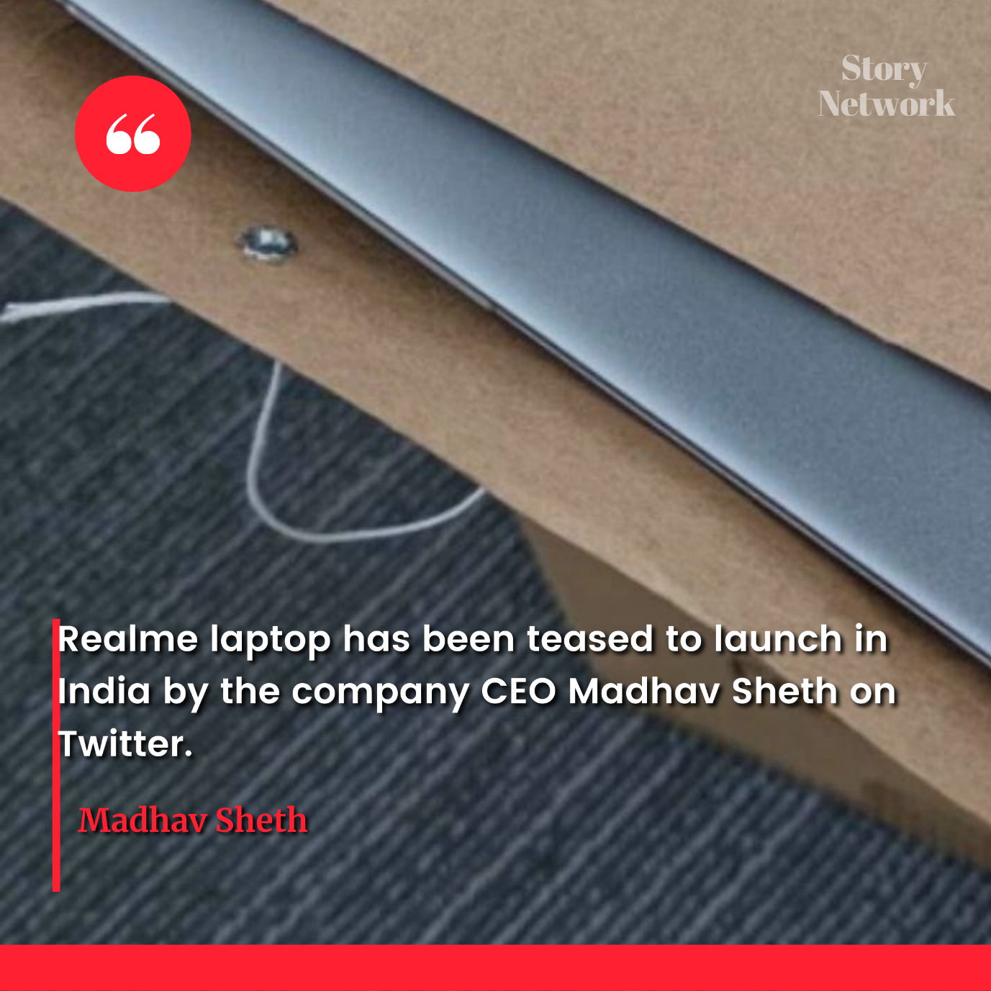

Realme Book laptop and Realme Pad tablet will be the two new upcoming products from the company, as per leaked images. Realme recently teased a laptop and a tablet, both of which will be the company's first in their respective categories. The leaked images not only hint at the names of the products but also show their design. The Realme Book images are reportedly of a prototype device and Realme Pad seems to have an iPad-like design. It is speculated that the two products will be launched during the Realme GT 5G smartphone's global launch this month.

As per the leaked images obtained by Android Authority, Realme is expected to soon launch a laptop called Realme Book and a tablet called the Realme Pad. Yesterday, Realme India and Europe CEO Madhav Sheth teased an upcoming laptop and company CMO Francis Wong teased a tablet. Now, images for both devices have surfaced, showing the design of Realme Book and giving a glimpse of Realme Pad.

3.



He is widely acknowledged to be one of the greatest physicists of all time. Einstein is known for developing the theory of relativity, but he also made important contributions to the development of the theory of quantum mechanics. Relativity and quantum mechanics are together the two pillars of modern physics. His mass–energy equivalence formula E = mc^2, which arises from relativity theory, has been dubbed "the world's most famous equation".

4.



Flipkart Big Saving Days sale will kick off Sunday, June 13 with big offers, deals, and discounts on various smartphones, tablets, laptops, wearables, and other electronic devices. The Flipkart sale, which will last until June 16, will offer an instant discount of 10 percent for SBI card customers over and above other deals. In terms of offers, smartphone models including the Google Pixel 4a, iPhone 11 Pro, Motorola Razr 5G, Samsung Galaxy F12, and Asus ROG Phone 3 will receive discounts during the four-day sale.

The Big Saving Days sale will go live on Flipkart starting on the midnight of June 12 for Flipkart Plus members. It will commence for regular customers from June 13.

5.



Musk initially teased the car's gaming capabilities in January 2020, when he tweeted, "Want to play The Witcher game on your Tesla? (you can already watch the show on Tesla Netflix theater)." More recently, Musk revealed that Tesla's Model S sedan features a 10-teraflop gaming computer, which would put the gaming hardware on par with the recently-released PlayStation 5 and Xbox Series X. Those gaming systems offer 10.28 teraflops and 12 teraflops of GPU power.

Tesla owners who have a knack for gaming can purchase playable games via the Tesla Arcade, which was first introduced in the Model 3 back in 2019. Both the first level of Cuphead and a car karaoke mode came to the company’s in-car software later that year, while Fallout Shelter was added to the cars in 2020. The new Model S also apparently has “wireless controller compatibility [which] allows gaming from any seat."